* The particle theory of matter describes the characteristics of matter.
* [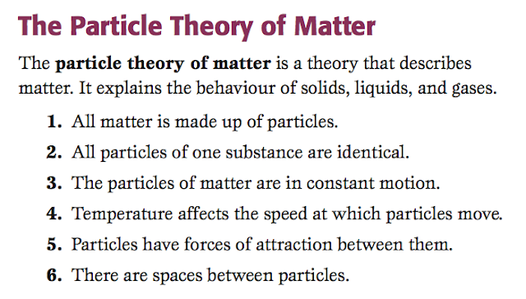](http://3.bp.blogspot.com/-Og_fmBpL8sQ/UYsYhGSGeDI/AAAAAAAAB6M/dgujhjxwjNE/s1600/Screen+Shot+2013-05-08+at+11.30.28+PM.png)

[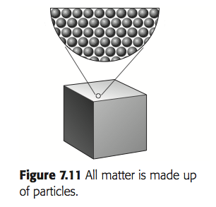](http://4.bp.blogspot.com/-T4DtZDdOpks/UYsY-OQqhDI/AAAAAAAAB6Y/MO4TULrJxBw/s1600/Screen+Shot+2013-05-08+at+11.32.00+PM.png)[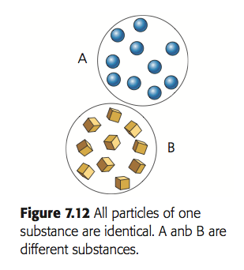](http://1.bp.blogspot.com/-iLrI4h2B0Ac/UYsY9xOd9qI/AAAAAAAAB6U/thyPFfJtbvw/s1600/Screen+Shot+2013-05-08+at+11.32.06+PM.png)

[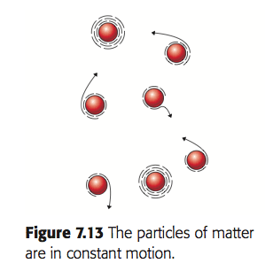](http://2.bp.blogspot.com/-MsZrFJfInic/UYsY-G7qtoI/AAAAAAAAB6c/V24Ph6rVwzg/s1600/Screen+Shot+2013-05-08+at+11.32.12+PM.png)[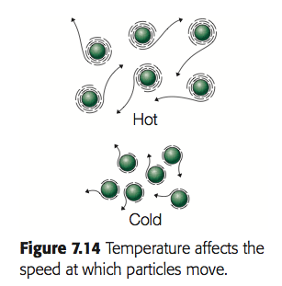](http://4.bp.blogspot.com/-UBuSJEkT86E/UYsY-d8nisI/AAAAAAAAB6g/hAcM8snRow4/s1600/Screen+Shot+2013-05-08+at+11.32.20+PM.png)

[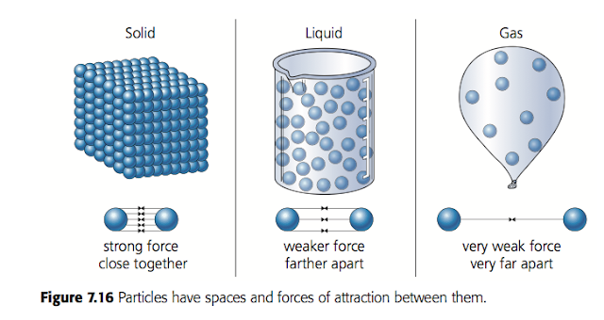](http://2.bp.blogspot.com/-hfUfgHFKq0I/UYsY-kLyuJI/AAAAAAAAB6o/44j1ochCzC8/s1600/Screen+Shot+2013-05-08+at+11.32.29+PM.png)

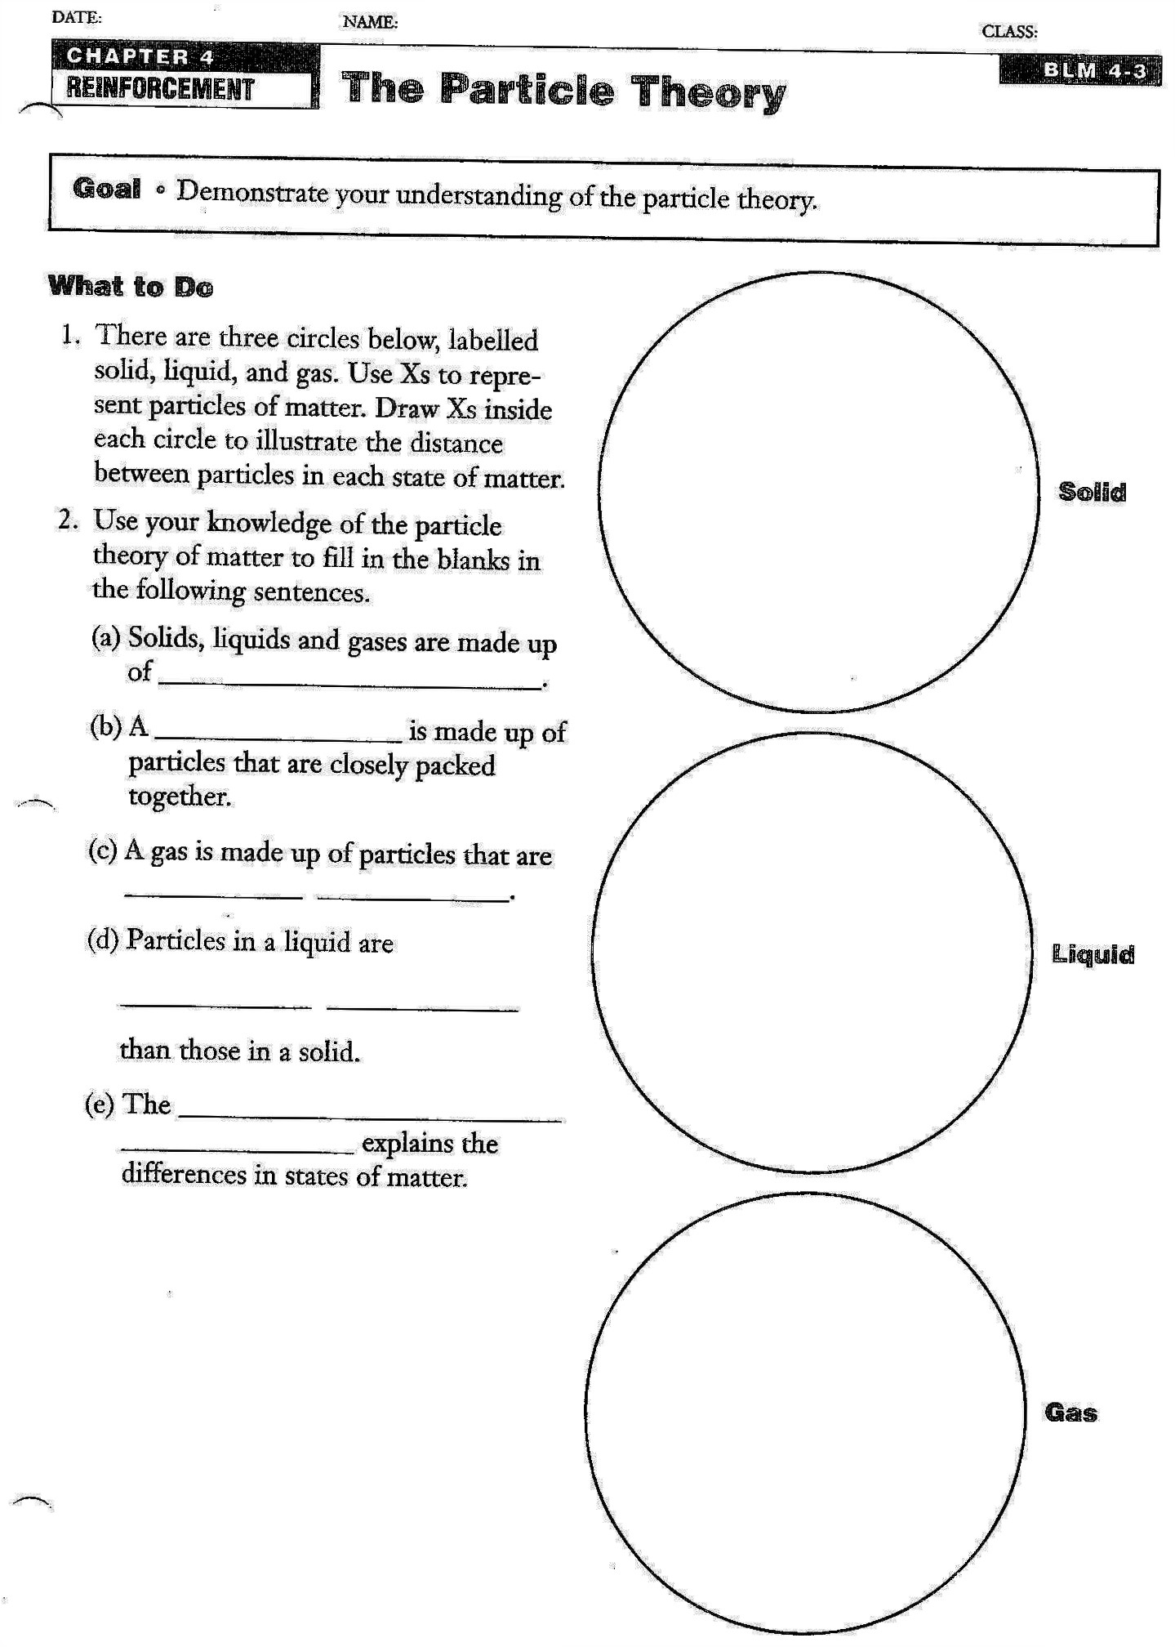

**WORD BANK**

Far apart

Farther apart

Particles

Particle theory

Solid